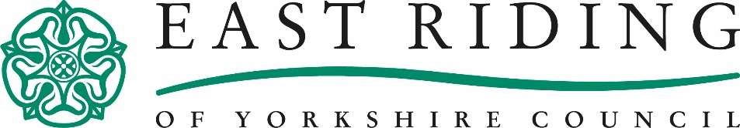
FIND OUT ABOUT FINANCIAL HELP AVAILABLE TO RESIDENTS
We are here to HELP.
The past 19 months has been a very unsettling time for many residents, with some people losing their job, furlough support ending and the temporary £20 uplift of universal credit and tax credits ending. As the winter months are upon us, we want to tell you about help available to residents, which could ease some financial pressures many will be under with the rise in energy bills.
What financial help are they eligible to?
The best way to find out is to use the council’s online benefit calculator, at https://eastriding.entitledto.co.uk
It’s free to use, anonymous and will help residents see what benefits they can claim and tell you how to apply. If a resident needs support to make an application, they can call out helpful call centre on (01482) 393939, however it is quicker to apply online using the links provided.

NEW Household Support Fund
Government announced on 30 September 2021 that it would provide councils funds to support residents with essentials over the coming months as the country continues to recover from the pandemic. It will help those who need it most, through small grants to meet daily needs such as food, clothing, and utilities. For more information visit http://www.eastriding.gov.uk/housing/housing-benefit-and-council-taxsupport/coronavirus-benefits-and-financial-support/

Help with food and utilities
The council has an emergency assistance scheme which aims to help residents if there has been an interruption to their normal income or require assistance when establishing themselves within the community. We can help with food and gas/electricity and other essential items. To find out more and apply http://www.eastriding.gov.uk/living/emergencyassistance/

Warm Homes Discount
If a person gets the Guarantee Credit element of Pension Credit or are on a low income, they could get a one-off payment of £140 off their electricity bill for winter 2021 to 2022. The money is not paid to them but taken off their bill. They can still apply if you have a prepayment meter.
To find out more and how to apply visit www.gov.uk/the-warm-home-discount-scheme. Please note, this is not the council’s scheme.

WaterSure
WaterSure is a scheme which helps some people with their water bills, they must be on benefits and need to use a lot of water either for medical reasons or because their household has a certain number of school-age children. They also need to be on a water meter or be waiting to have one installed.
If they get help through the WaterSure scheme, their water bill will be capped. This means they will not pay more than the average metered bill for the area thier water company deals with. To find out more visit the water suppliers website. Please note, this is not the council’s scheme.

Help with rent and council tax
Residents might be entitled to help towards rent and council tax if they are on a low income and have less than £16,000 in savings? All the details and to make an application can be found on the council’s website at https://www.eastriding.gov.uk/benefits If a resident needs support to make an application, they can call out helpful call centre on (01482) 393939, however it is quicker to apply online using the links provided.

Universal Credit
Universal Credit is a payment to help with living costs. It’s paid monthly. Residents may be able to get it if they are on a low income, out of work or you cannot work.
More information and to apply www.gov.uk/universal-credit

Free school meals
Many families with children at school will be entitled to free school meals for their children. More information and to apply can be found at www.eastriding.gov.uk/fsm.

Council Tax Reductions
The Council Tax system provides support to help people in various circumstances or who might otherwise struggle to pay. There are many discounts and exemptions that can be applied to Council Tax.
Generally, if a Council Tax exemption applies, no Council Tax will need to be paid on the property. If an exemption doesn’t apply, but a person qualifies for a discount or disregard, they will receive a reduced bill.
To find out if they are entitled to a discount or exemption on council tax visit www.eastriding.gov.uk/counciltax
What should I do if I am having difficulty paying my rent or council tax?
The first thing you need to do is let us know. If we don’t know you’re having difficulties, then we can’t help you, call us on (01482) 393939.
We have a dedicated Welfare Team who can help with even the most complex situations, who can make sure you are receiving all of your entitlements. To speak to one of our advisors email benefit.takeup@eastriding.gov.uk asking for an appointment.

I do hope that you will find this information useful in supporting our residents.

Gillian Barley Lisa Martindale
Head of Revenues & Procurement Revenues and Benefits Group Manager

